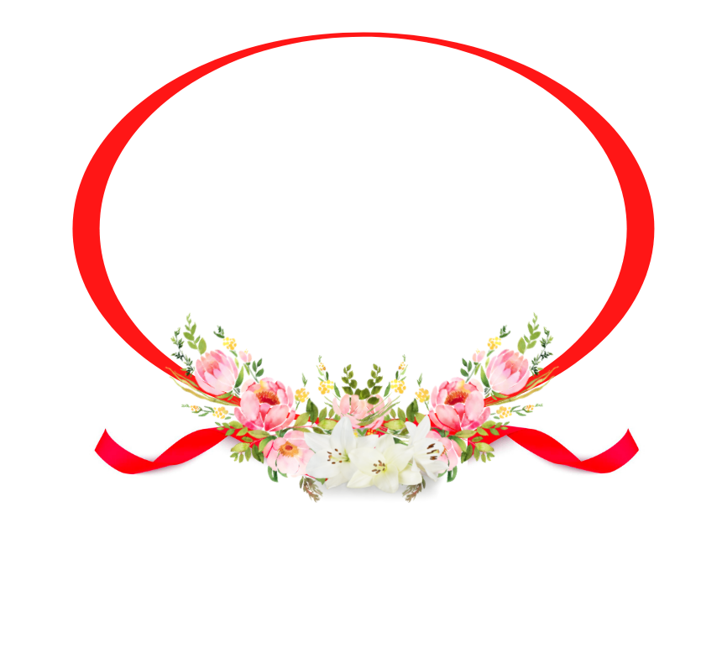

Happy Birthday!

Mama Lita